The
Parent House Newsletter

Summer/Autumn 2023

There have been some exciting developments during the summer term. Our Parent Voice team have met with over 60 Islington parents to find out your views. Our Wellbeing group have filled the house with calming and energising aromas and have welcomed over 40 parents into their group. Our outreach team have travelled across Islington to meet parents wherever they can find you. We are winding down for our summer break now but will be back in September. We hope that you have some lovely times in the sun and that you can join us for workshops, courses and whatever else you need in September.
How can we support you?

The Parent House are here to listen! At the house you will meet other parents and share ideas and concerns. We offer unique training with parent’s wellbeing at our heart. We can help you with food projects, linking you to other services training, workshops, hardship funds and much more.

All Islington parents can Join us by completing our registration form. Just follow the link or use the QR code https://www.surveymonkey.co.uk/r/SSBVS9W
You will receive regular updates about all of our services and events. Tell us what you want and need.
contact us on: 0207 837 1383 or email info@theparenthouse.co.uk

How to
Communicate Effectively
Free Course for Islington Parents

In 2022 parents told us that they were deeply affected by the lockdown and the struggles caused by Covid 19. One of your concerns was communication. Conversations with children, teenagers, schools and other services became more difficult. We were asked for workshops and courses that would help.
In September we are starting a 10-week course
Where you will:
- Develop listening skills
- Explore your creative side
- Express yourself, so that you are heard
- Grow in confidence in a group setting

Meeting other parents, sharing ideas and having fun is a great step towards happier and more effective communication
Days: Thursdays
Time: 9.30am to 12.30pm

To find out more or book a place please contact us on 0207 837 1383 or Anita@theparenthouse.co.uk Use these details to contact us for any reason
Autumn Timetable for All Courses and Projects
 | Morning | Afternoon
Monday |  | One to one time: You talk, we listen and support
Tuesday | SEND Friends – (fortnightly alternating) 10am to 12pm | Outreach (fortnightly alternating) 12.30pm to 2.00pm
Wednesday | Parent Voice – weekly  9.30am to 12pm | Mindfulness - weekly  1 to 2.30pm  OPEN FOR NEW PARENTS
Thursday | Effective Communication weekly  9.30am to 12.30pm  OPEN FOR NEW PARENTS | ESOL – weekly ACL  1 to 2.30pm  OPEN FOR NEW PARENTS
Friday | One to one time: You talk, we listen and support

Wellbeing
Wednesdays

Free for Islington Parents

Make
- Cleaning products for your home
- Fragrances made of natural oils
- Natural scrubs

Learn
- Meditation techniques
- Breathing exercises
- Reflexology

Connect
- Meet other parents

The Parent House and Islington Healing Network will bring you eight relaxing wellbeing workshops throughout September, October and November 2023.
Starting on Wednesday 13th of September and continuing until the end of term, you will be will guided through calming, soothing and tranquil sessions that will help you to find some balance and peace in your busy day/week/life.
there will be space and time for everyone. If you need a reason to get out of the house, this is it!
Days: Wednesdays
One parent told us
‘When I walk out of there I'm always left feeling uplifted and positive and ready for whatever the world has in store for me.’

Time: 1pm to 2.30pm

To book a place please call 0207 837 1383 or email Anita@theparenthouse.co.uk
If you don’t know The Parent House already this is a good way to meet us and experience our warm welcome.

On the 29th of June we celebrated our 23rd birthday with an open day, and the sun shone on us
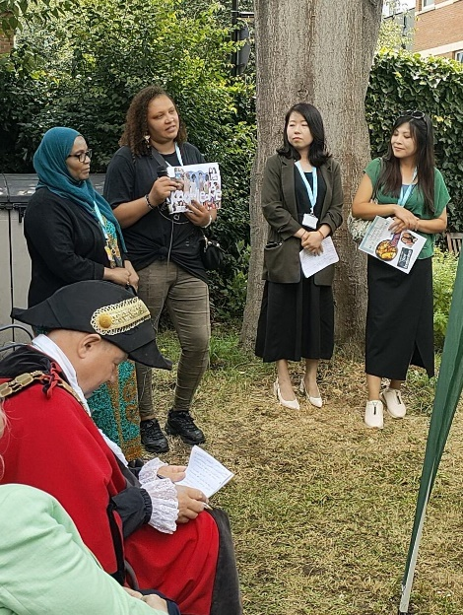
We celebrated with gorgeous food which reflected the diversity of the parents who make up our house. Kisha Nichols won our volunteer of the year award, because of her tireless, positive and sensitive approach to her role at TPH. It was almost impossible to choose a winner, we have so many excellent volunteers at the house, who make research, promote our courses and support other parents.
The Mayor visited and made a rousing speech. He had such a lovely time that he stayed for the whole day.
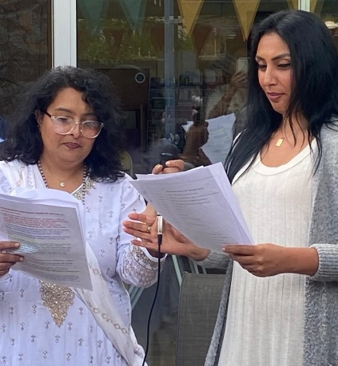
Massive thanks to Play- Make -Do who linked up with us for the day to provide an exciting play place for the children who built dens and made art with real tools. We plan to do more work with them in the future. Islington Healing Network also ran a practical and popular workshop where parents made aroma therapy roller fragrances to take home. We will be running more of these workshops in September.
All of the parent groups gave presentations, which included a quiz from SEND Friends, Collages from Outreach volunteers and a hilarious sketch from Parent Voice. There was also a song from Parent Voice too ‘We’re stronger together’ which brought a tear to a few eyes
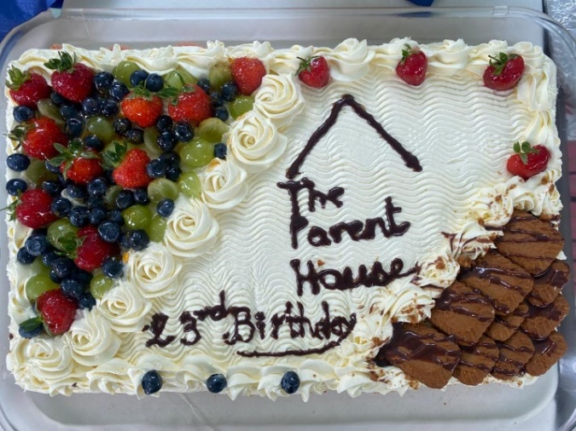
There is so much to celebrate at The Parent House – the groups continue to develop and support each other in generous and interesting ways.
Thank you to all the parents who come to the house and make this place so warm and welcoming!

Cost of Living Research

2023 has been a very difficult year for parents; they faced rising food prices, and energy bills increasing in unmanageable ways.
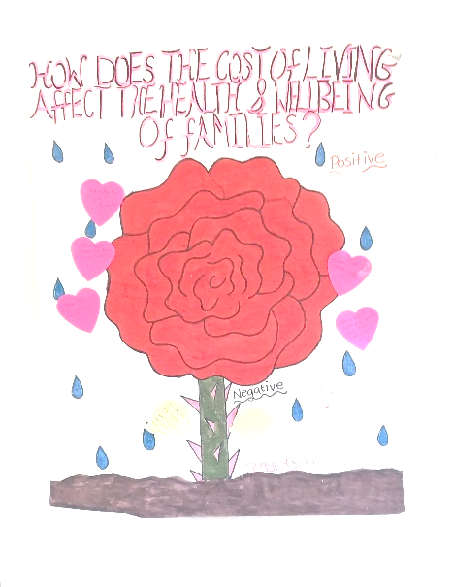
We know it was hard because our Parent Voice group went out in to Islington to speak with parents about their experience of the Cost of Living Crisis. They visited local venues, including All Change Arts and The Bridge School where they gathered information about what parents feel, think, want and need.
Some of parents spoke about ‘Low mood, negative thoughts, fearful of what will happen tomorrow’ another said ‘people were hungry but not going to food banks because of stigma’ they also talked about how the crisis effects their children.
As well as talking about their worries, parents gave tips to each other. One piece of advice that came up over and again, from parent to parent, was that it was good to speak to your children about what is happening with prices (depending on the children’s age). Children can sometimes cope better when they understand what’s going on.
Parents who took part also said that being heard and speaking together made them feel better. One parent described the sessions as
‘A supportive environment to share hardships without judgement’

Now that the Parent Voice group has found out what parents want, they are planning three free workshops for the Autumn term with themes suggested by the parents they met. We will share dates and themes in September.

The Parent House is a listening organisation
We are here to support Islington parents

We can offer one to one support to any Islington parent. Call or email and we can set up, either a face to face support session, or a support phone call.

- A person to listen to you
- Signposting to useful services
- Accredited courses and projects
- Volunteering opportunities
- Food bank vouchers
- Free clothes for children
- Much more
Contact us: 0207 837 1383
Michelle@theparenthouse.co.uk
Joanne@theparenthouse.co.uk

The Parent House: 55 Calshot Street, N1 9AS
www.theparenthouse.org

We would Love you to Join us on Twitter and Instagram
Find us by following @theparenthouse
Parents

We see a parent as any adult who looks after children in their own home: If you are a grandparent, a foster parent, a sibling guardian or an auntie or uncle who is bringing up children, then we see you as a parent and want you to join our community.

